SQL
Session-7
Q1. Create a table called Restaurant with columns: id, name, location, and cuisine. Apply NOT NULL constraint to name and location, and make id the PRIMARY KEY.
CREATE TABLE Restaurant (
id INT PRIMARY KEY,
name VARCHAR(20) NOT NULL,
location VARCHAR(20) NOT NULL,
cuisine VARCHAR(25) );
Output-
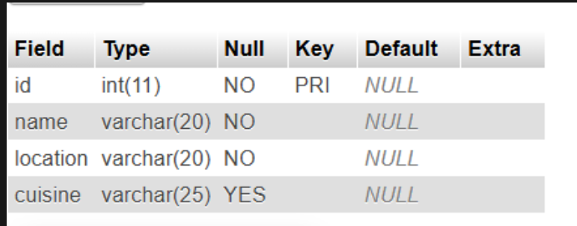

Q2. Create a table called FoodOrder with columns: order_id, restaurant_id, user_id, and order_total. Set order_id as PRIMARY KEY, and add a FOREIGN KEY constraint on restaurant_id referencing Restaurant(id).
CREATE TABLE FoodOrder (
order_id INT PRIMARY KEY,
restaurant_id INT,
user_id INT,
order_total DECIMAL(10,2),
FOREIGN KEY (restaurant_id) REFERENCES Restaurant(id)
);
Output-
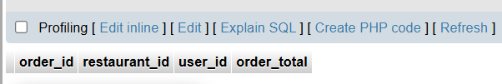

Q3. Insert 6 rows into a table called SpotifyUser with columns: user_id, username, email, and subscription_type. Ensure that username is UNIQUE and email is NOT NULL.<br><br><em><strong>Hint:</strong> Use the UNIQUE and NOT NULL constraints when creating the table.</em>
CREATE TABLE SpotifyUser (
user_id INT PRIMARY KEY,
username VARCHAR(20) UNIQUE,
email VARCHAR(20) NOT NULL,
subscription_type VARCHAR(25)
);
INSERT INTO SpotifyUser
(user_id, username, email, subscription_type)
VALUES
(1, 'neha_05', 'neha@gmail.com', 'Premium'),
(2, 'sanjna_12', 'sanjna@gmail.com', 'Free'),
(3, 'abhishek_6', 'abhishek@gmail.com', 'Premium'),
(4, 'rishi_10', 'rishi@gmail.com', 'Premium'),
(5, 'shreya_16', 'shreya@gmail.com', 'Free'),
(6, 'diya_20', 'diya@gmail.com', 'Premium');
Output-
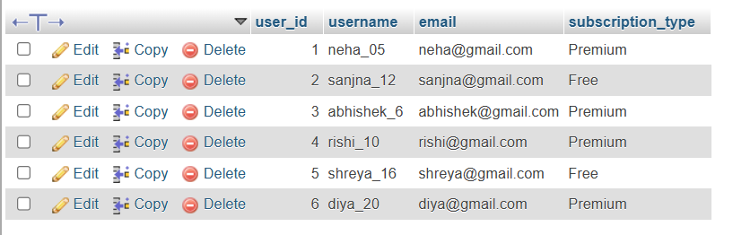

Q4. Create a VIEW named TopSpendersView that shows usernames and order_total from a FoodOrder table where order_total is greater than 1000.
CREATE VIEW TopSpendersView AS
SELECT SpotifyUser.username, FoodOrder.order_total
FROM SpotifyUser
JOIN FoodOrder
ON SpotifyUser.user_id = FoodOrder.user_id
WHERE FoodOrder.order_total > 1000;
Output-
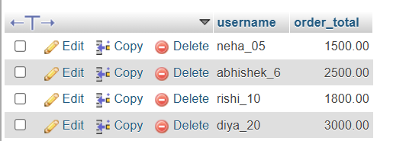

Q5. Write a SQL query to list all users from the TopSpendersView who have spent more than 2000, sorted by order_total descending.
Constraint: Only use the TopSpendersView for your query, not the original FoodOrder table.
SELECT username, order_total
FROM TopSpendersView
WHERE order_total > 2000
ORDER BY order_total DESC;
Output-
